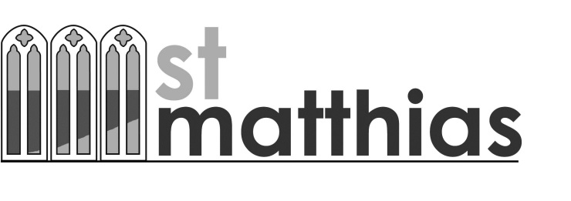
Fourth Sunday after Trinity
Sunday 28 June 2015

Welcome!
We are delighted to see you, especially if this is your first visit.
Please do join us for refreshments in the hall after the 10.30am service.

Today
8am | Holy Communion (BCP)
10.30am | Confirmation Service with Bishop Robert
During the Week
Mon | 7.30pm Friends of St Matthias meeting - Lounge
Tues | 9.30am ‘Open House’ parents & toddlers - Lounge
Wed | 9am Holy Communion followed by coffee in the Lounge
 | 12pm Josiah Lunch in the Hall
 | 7-8pm Prayer Meeting – Rose Price room
Thurs | 10.30-11.30am Prayer Meeting – the Ark
Sunday 5 July
8am | Holy Communion (BCP)
9.30am | Breakfastzone in the Hall with breakfast from 9.15am
10.30am | Holy Communion (CW)

Today we welcome Bishop Robert to our service for a special service of Confirmation. We continue to look at the work of the Holy Spirit – this week at how He enables us to know that we are God’s children, and also helps us to pray.

What’s On
Rowcroft Sleep Walk Liz Sampson, Pauline and the Pre-School team, Elaine Biden, Lindsay Doidge, Judi Stannard, Lorraine Myrie are all walking to raise money for Rowcroft on 11 July. If anyone is able to sponsor any of us we would be delighted!

Church Magazine Summer edition available in church today.

Correction in magazine Men’s Breakfast on 11 July will be at the Kent’s Cavern not the Palace Hotel. Contact c.allansen@btinternet.com for details or to book.

St. Matthias Pre-School – A BIBLE FOR A CHILD We would like to present a children’s Bible to each of our 29 children leaving the Pre-School in July. We hope that the parents may read the stories to the children and that the Bible would be treasured in years to come. Each bible costs £8.50. If you would like to ‘Buy a Bible’ or donate towards the cost, please put your donation in a blue envelope in the pews, write ‘BIBLES’ on it and put it in the collection. Even better, if you are a tax payer please put your name and address (or giving number) on the envelope so that it can be gift-aided. Please offer a prayer for the recipient as you give your gift. Thank you so much. Sylvia Barratt (Chair of Management Committee)

Holy Communion Distribution The recent scaffolding has forced us to experiment with yet another way of distributing bread and wine at our Holy Communion services. So, currently we are all receiving standing up from four places near the Communion Table. We actually think this may be a good way to continue (but without going up and down the dais step). It is much better for those who find it hard to kneel and it makes it much more likely we finish our services by 11.45! However we realise it is a change for many, so please let us know if you have strong feelings about it by filling in a comment in the pink ‘Pere’s Book’ at the back of church. John

Litter Picking at Hope’s Nose on Wed 1 July 10.30-12.30pm – help appreciated for this Site of Special Scientific Interest.

Charlie and Janie’s wedding on 15 August Please sign up at the back of church if you would like to attend the ceremony and cream tea after the service. The list will close on the second Sunday in July so that preparations can be made.

Large inflatable boat found in the West Porch. If it belongs to you please collect as soon as possible before it floats away…

Health & Safety If you have any experience of Health & Safety the church urgently needs someone to help with this. Please see the church wardens.

DIY Does anyone have any DIY skills and some spare time? We are trying to put together a team of people who would be happy to be called on from time to time (on a rota basis) to help with some basic tasks around the church and centre eg putting up noticeboards, mending curtain rails, fixing kitchen cupboards…..and similar small jobs. Please contact Pere in the office if you would like to help.

Choral Evensong at St John the Apostle, Torquay 12 July at 6.30pm To commemorate the 70th anniversary of the ending of the Second World War.

Over 60s – we need you!
Your views are important. How can St Matthias meet the needs of the ‘over 60s’ within the church family and in the local community on a Sunday and also during the rest of the week? Come and air your views and enjoy a cream tea on Thursday 16 July from 3-5pm in the Peter Larkin Hall. Why not bring an ‘over 60’ friend? They will be very welcome. Register your interest by signing the notice on display in the Peter Larkin Hall.

Sunday 12 July 11am
Open Air Service on
Ilsham Green
followed by Church Family BBQ (to raise funds for the
Youth Bank)
Hot dogs and burgers £2 & £2.50 and a vegetarian option.
This service is in place of our
All Age Worship service in church but there are lifts available from church at 10.30am.
Please bring any garden chairs or rugs to sit on.

Help needed for Open Air Service
We need a ‘green team’ from 9am to put up and take down gazebos. Please let John Beckett or Phil Miles know if you can help. Thank you.

Readings for Today
John 3 (NRSVA)

³ Now there was a Pharisee named Nicodemus, a leader of the Jews. ² He came to Jesus by night and said to him, ‘Rabbi, we know that you are a teacher who has come from God; for no one can do these signs that you do apart from the presence of God.’ ³ Jesus answered him, ‘Very truly, I tell you, no one can see the kingdom of God without being born from above.’ ⁴ Nicodemus said to him, ‘How can anyone be born after having grown old? Can one enter a second time into the mother’s womb and be born?’ ⁵ Jesus answered, ‘Very truly, I tell you, no one can enter the kingdom of God without being born of water and Spirit. ⁶ What is born of the flesh is flesh, and what is born of the Spirit is spirit.⁷ Do not be astonished that I said to you, “You must be born from above.” ⁸ The wind blows where it chooses, and you hear the sound of it, but you do not know where it comes from or where it goes. So it is with everyone who is born of the Spirit.’

Romans 8 (NRSVA)

¹⁴ For all who are led by the Spirit of God are children of God. ¹⁵ For you did not receive a spirit of slavery to fall back into fear, but you have received a spirit of adoption. When we cry, ‘Abba! Father!’ ¹⁶ it is that very Spirit bearing witness with our spirit that we are children of God, ¹⁷ and if children, then heirs, heirs of God and joint heirs with Christ —if, in fact, we suffer with him so that we may also be glorified with him.¹⁸ I consider that the sufferings of this present time are not worth comparing with the glory about to be revealed to us.

¹⁹ For the creation waits with eager longing for the revealing of the children of God; ²⁰ for the creation was subjected to futility, not of its own will but by the will of the one who subjected it, in hope ²¹ that the creation itself will be set free from its bondage to decay and will obtain the freedom of the glory of the children of God.

²² We know that the whole creation has been groaning in labour pains until now; ²³ and not only the creation, but we ourselves, who have the first fruits of the Spirit, groan inwardly while we wait for adoption, the redemption of our bodies.²⁴ For in hope we were saved. Now hope that is seen is not hope. For who hopes for what is seen? ²⁵ But if we hope for what we do not see, we wait for it with patience.²⁶ Likewise the Spirit helps us in our weakness; for we do not know how to pray as we ought, but that very Spirit intercedes with sighs too deep for words.²⁷ And God, who searches the heart, knows what is the mind of the Spirit, because the Spirit intercedes for the saints according to the will of God.²⁸ We know that all things work together for good for those who love God, who are called according to his purpose.

Collect for Today
Gracious Father,
by the obedience of Jesus
you brought salvation to our wayward world:
draw us into harmony with your will,
that we may find all things restored in him,
our Saviour Jesus Christ. Amen

Suggested topics for our personal prayers this week

Today | We pray for our Bishop Robert as he leads the Confirmation Service. Please pray that he will be inspired by God’s Holy Spirit as he preaches and confirms the candidates. Pray for the candidates that they may all have a special infilling of the Holy Spirit and be ready to go out and serve the Living God.
Mon | Pray for all our schoolboys and girls as they reach the end of term. Pray especially for those leaving or changing schools. May they know God in their lives helping them to handle the changes. Pray for them all as they prepare for holidays, praying they may use the time positively and safely.
Tues | Pray for the preparations for the young people's holiday club and for all who will be helping.
Wed | Pray for all those already preparing for the open air service on Ilsham Green (12 July). Pray that it will be a really inspiring time as well as a fun time; and may it be a witness to any using the Green or driving by.
Thurs | We remember all who we know are sick or finding life hard, especially those who cannot get to Church. May they know our Lord's presence with them healing or touching any point of need. Pray, too, for members of our families separated by many miles. We entrust them to God's care and protection.
Fri | Pray for all around our world who are suffering persecution, danger or homelessness. We pray for a solution to all the political or social deprivations.
Sat | We pray for all our leaders in Church and State - we pray specifically for our Member of Parliament Kevin Foster and our Councillors. In the church we pray for our Archbishops, Archdeacons, and Priests.
Sun | Pray for John and Ruth Beckett, Paul and Tessa Barton, Brian and Norma Gerry, Ruth Jones and Steve and Amanda Vans-Colina and all in leadership roles. Pray for our services today, that we may all be aware that we worship an Awesome and Living God and that we stand on holy ground.

Social Core Events
for the whole church family:

Sun 11 Oct Harvest Lunch
Sat 31 Oct Jollyween
Sat 21 Nov Coach trip to Cardiff

Creche, Toilets, Baby Changing Facilities
At 10.30 communion services there is a staffed crèche in the Lounge downstairs, but if you wish to stay in the service, toys are available at the back of the church. Baby changing facilities are available in both toilets on the lower ground floor. There is a disabled access toilet at this level on your left as you exit church.

Contacting the Church
St Matthias Church Centre, Babbacombe Road, Torquay, TQ1 1HW
Tel: 01803 214175
www.st-matthias-church.org email: pere.snow@st-matthias-church.org
Rector: John Beckett: 01803 293119 jandrbeckett@outlook.com
Curate: Paul Barton: 07807 636470 RevPaulBarton@gmail.com

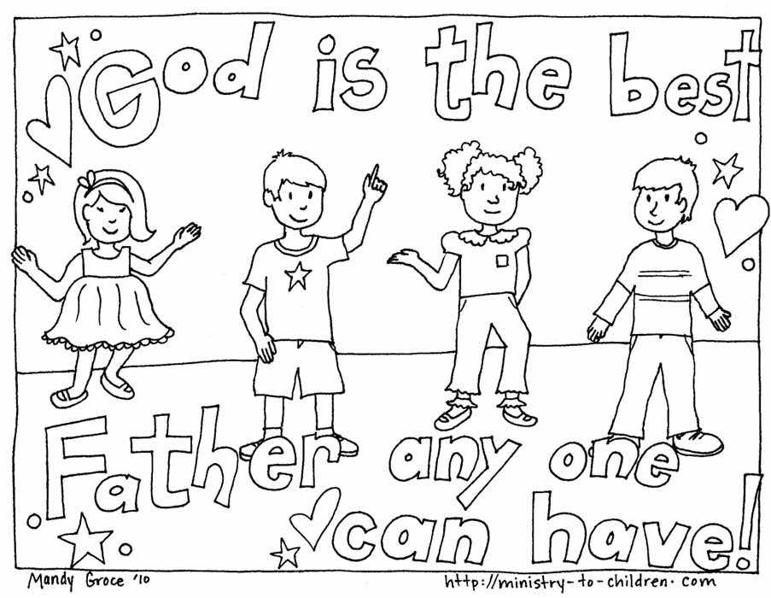
St Paul says: “God’s Spirit makes us sure that we are God’s children” (Romans 8)

